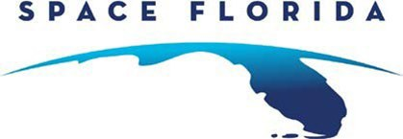

MARKETING COMMITTEE MEETING
Agenda

Friday, February 24, 2023
11:00 a.m. EST

By Teleconference
Call-in Number: 855-758-1310
Guest Code: 627 763 6389#
Passcode: 567768

Agenda Items
Call to Order | Sonya Deen Hartley
Agenda  - Public Comment  - Meeting Charts  - Background Materials | Sonya Deen Hartley  Howard Haug and Senior Executives
Closing Remarks | Sonya Deen Hartley

